Q&A “Alliance for YOUth”
Press Briefing EU & Belgian Media
Version final- 27 May 2015

- The “Alliance for YOUth”
- Results “Alliance for YOUth”
- Nielsen Employer survey

- The “Alliance for YOUth”

What is the “Alliance for YOUth” about?
The “Alliance for YOUth” is an Alliance of leading companies in Europe who recognize that youth unemployment is a major social and economic issue in Europe and are committed to helping to solve it. This business-driven movement aims at promoting a better transition from education and training to employment for our youth across Europe. The “Alliance for YOUth” wants to be a change agent in sharing knowledge and experiences to solve local barriers to youth employment.

The “Alliance for YOUth”, founded by Nestlé, has a broad membership and all the companies involved have pledged to:
- Be an active member of the European Commission's "European Alliance for Apprenticeships" – promoting apprenticeships and training and being active ambassadors for this approach across Europe.
- Develop a number of joint initiatives to give young people meaningful work experience and internships.
- Mobilise employees to go out into the community and help young people get 'Ready for Work' by offering CV preparation and interview advice.

We believe the public sector has a role to play in putting the right measures in place to favour the employability of young people. That said the private sector is the largest employer in Europe and its mobilization can change the course of things. This is the spirit of the “Alliance for YOUth” which mobilizes international as well as small and medium sized companies.

Who did initiate the “Alliance for YOUth”?
As part of Nestlé’s Youth Employment Initiative “Nestlé needs YOUth”, Nestlé invited its 63 000 European suppliers to join the “Alliance for YOUth” by letter. On top of this Nestlé reached out pro-actively to key suppliers at both European and local level. This has led to a list of about 200 partners that have agreed to become a partner of the “Alliance for YOUth”. For each partner we identified an internal sponsor supporting our partners in their journey to set-up their own programme to address youth employment. Nestlé has now also started to engage with its customers (eg. Sonae and Jerónimo Martins in Portugal).

Which Partners have already joined the “Alliance for YOUth”?
Adecco, AXA, Cargill, Chep, DS Smith, EY, Facebook, Firmenich, Google, Nielsen, Nestlé, Publicis Groupe, Salesforce, Twitter, White&Case are the founding European partners of the Alliance. In total, close to 200 companies from across Europe have already joined the Alliance. We continue to discuss with more potential partners. You could find the full list on our website: http://www.nestle.com/asset-library/documents/media/events/a4y2014/alliance-for-youth-local-partners.pdf

You have made this commitment to the “European Alliance for Apprenticeships”. What is this European Commission initiative about?
We very much support the objectives of the “European Alliance for Apprenticeships” (EAfA) which are completely aligned with “Alliance for YOUth” initiative. EAfA is a European Commission initiative promoting the uptake of quality apprenticeship schemes across Europe through a multi-stakeholder approach. Nestlé has been a founding signatory to the “European Alliance for Apprenticeships” when it was launched in 2013 in Leipzig.
Together with the European Commission we strongly believe that the German, Austrian, Swiss tradition of apprenticeship schemes should be introduced across Europe to strengthen the employability of the European Youth.

Why is the “Alliance for YOUth” organising joint communications at European level?
“Alliance for YOUth” companies are committed to work hand in hand with policy-makers to address youth unemployment and foster both job employability and job creation.
In order to be able to work closely with the new political leadership at European level we are familiarising them with our initiative and its progress. This will allow the “Alliance for YOUth” to further strengthen our contribution and the European policy-makers to propose the right policy framework in support of the dual learning schemes.

Have you already engaged your business associations as well?
Yes, we have been pro-actively engaging with a number of European business associations such as European Roundtable of Industrialists (ERT), FoodDrinkEurope and AIM to engage as well their membership.

FoodDrinkEurope has made a joint pledge with EFFAT (European trade union for the food industry) last October. They are committed to facilitate the uptake of trainee and apprenticeship schemes across the almost 280 000 food companies (of which 99.9% are SMEs) in the EU. Best practices will be established and shared broadly.
http://www.fooddrinkeurope.eu/uploads/press-releases_documents/FoodDrinkEurope_EFFAT_Pledge.pdf

AIM (European Brands Association) has made a joint pledge with the European Youth Forum (EYF) to support the delivery of “Skills for the Future” for the European Brand Manufacturers. At the same time AIM is promoting quality internships by supporting the roll-out of the European Youth Forum’s quality charter assessment tool.

Within the European Roundtable of Industrialists (ERT), we are sharing our experience and are contributing to a “best practices” guide.

Members of the “Alliance for YOUth” will also act as ambassadors to advocate to their respective business partners and business associations in a similar approach to create a further positive impact and a snowball effect.

- Results “Alliance for YOUth”

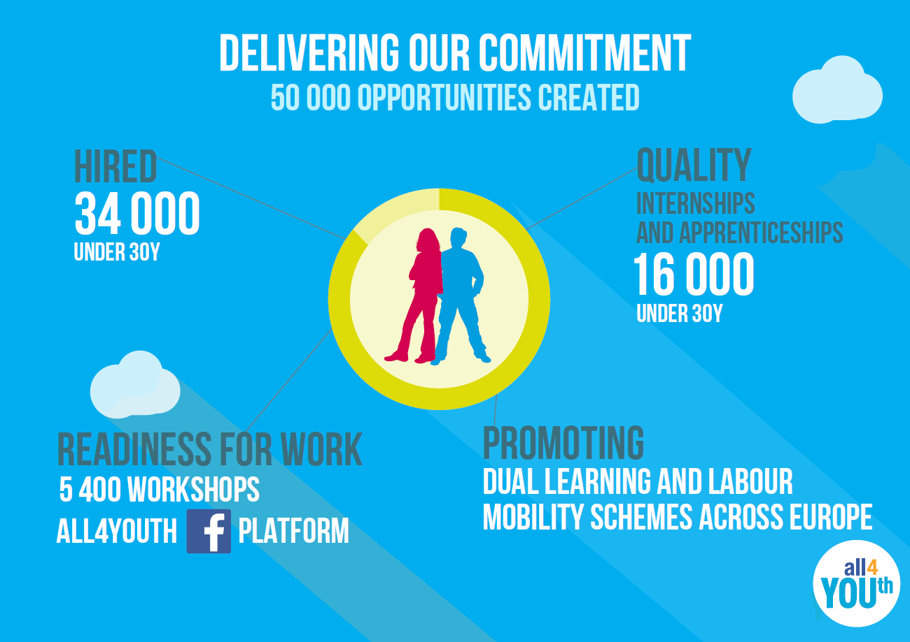

What are the results of the “Alliance for YOUth” one year after signing their joint pledge to the “European Alliance for Apprenticeships”?
On 23 June 2014 the European founding partners made a joint pledge to the “European Alliance for Apprenticeship”. The “Alliance for YOUth” committed to generating more than 100 000 job and training opportunities for young people in the coming years (3 years).
The below results are from the 15 European founding partners during the first 12 months. In total we created 50 000 job and training opportunities:
- 34 000 regular and temporary employees were hired;
- 16 000 young people were offered traineeships and apprenticeships;
- Readiness for work activities:
  - 5400 Readiness for work workshops were organized with an estimated 6000+ volunteers from the “Alliance for YOUth” companies
  - Launch of "All4YOUth", a new social platform on Facebook aimed at helping young people find a job. The platform has been designed by young people with powerful content linked to job offers, CV advice or job interview tips presented in a creative and youth friendly tone.
- We have been setting up dual learning and labour mobility schemes across Europe

Can you give a more detailed split of these results?
16000 training opportunities: 4000 apprenticeships and 12000 internships
34000 job opportunities: 26 000 regular employment and 8000 temporary contracts

Can you share the number of opportunities created on a company by company basis?
It is up to the individual companies to communicate their individual results.All “Alliance for YOUth” companies will report back their respective achievements through the annual reporting organised by the European Commission under the umbrella of the European Alliance for Apprenticeships. This will also be made public on the website of the European Commission. (http://ec.europa.eu/education/policy/vocational-policy/alliance_en.htm).

- Nielsen Employer Survey

When was the survey realized?
March 2015, results were consolidated in May 2015.

Who participated in the survey?
635 Managers and HR professionals from 70 “Alliance for YOUth” companies in 22 countries.

Your survey says that the “Alliance for YOUth” has increased collaboration among stakeholders. Can you give some examples?
Inside the Alliance: in Portugal, “Alliance for YOUth” partners are meeting regularly to work on implementing a local “Alliance for YOUth” agenda (eg. promoting vocational and educational training).
Outside the Alliance: when setting up dual learning schemes we are working in close cooperation with schools & universities in the proximity of our operations.

What kind of administrative barriers are you referring to in the survey conclusions? Example?
Setting-up apprenticeship schemes involves negotiating with schools and local authorities to establish the best possible learning programs. Schools and local authorities must have a high degree of flexibility, be it pedagogical, financial or administrative to be able to seize opportunities that companies can provide. Many administrative issues, such as approval of changes to official curricula, need to be solved and procedures are different within the EU and even within a given country. This might discourage potentially interested companies to set up such dual learning schemes.

What do you mean by “we could create more opportunities for Apprentices & Interns with financial support from Governments”? Are you asking taxpayers to fund jobs/training in your companies?
Funding should be directed at setting-up dual learning schemes across Europe. Countries like Germany and Austria have shown that these schemes are improving the employability of the European youth now and in the future, notably by addressing the skills mismatch. They create new capabilities and ways of collaboration that are transferable to other companies/schools and regions. The “Alliance for YOUth” is advocating this model.

Funding of such schemes will be sustainable over time and benefit the young person and the society as a whole. Statistics show that young people who completed quality internships are more likely to find a job that those who didn’t.

***

